

Basketball League Management System
A MINI PROJECT REPORT
Submitted by
Ashutosh Dash (26MCD10089)
in partial fulfilment for the award of the degree of
Masters of Computer Applications
IN
Data science
2026-28


Chandigarh University
2026-28
BONAFIDE CERTIFICATE
Certified that this project report “Basketball League Management System” is the bonafide work of “Ashutosh Dash, UID: 26MCD10089” who carried out the project work under my/our supervision. The content and findings presented herein are authentic and reflect the original work conducted during the course of this project.

Name: Ashutosh Dash | Name: Ms. Winky Bhatia
UID : 26MCD10089 | Designation: Assistant Professor
Department: MCD - 2 | SUBJECT CODE : E18463
SIGNATURE | SIGNATURE
Submitted for the project viva-voce examination held on

ACKNOWLEDGEMENT
I would like to express my deepest gratitude to everyone who contributed to the success of this mini project. Developing a complete database project with stored functions, procedures, triggers and a cursor in MySQL presented several challenges, and I am grateful for the support and guidance I received along the way.
I extend my sincere appreciation to the Head of Department, MCA, for the support and encouragement given throughout this project. I owe a special debt of gratitude to my subject faculty and project supervisor, University Institute of Computing, whose guidance, expertise and motivation helped me overcome obstacles and clear my doubts.
I also thank all the faculty members of the UIC department for their valuable suggestions, and my parents for their constant belief and motivation. Without their love and support this achievement would not have been possible.
Ashutosh Dash, UID: 26MCD10089

TABLE OF CONTENTS
Sr. No. | Chapter / Section Name | Page No.
 | Abstract | 3
1. | Introduction | 5
1.1 | Project Scope and Project Planning | 5
1.2 | Client Identification and Recognition of Need | 5
1.3 | Recognition of Relevant Contemporary Issues | 5
1.4 | Task Identification | 5
1.5 | Technologies Used | 5
1.6 | Timeline of the Project | 6
2. | Literature Review / Background Study | 6
2.1 | Timeline of the Reported Problem and 2.2 Existing Solutions | 6
2.3 | Bibliometric Analysis and 2.4 Review Summary | 6
2.5 | Problem Definition and 2.6 Goals / Objectives | 6
3. | Design Flow / Process | 7
3.1 | Evaluation and Selection of Features | 7
3.2 | Design Constraints and 3.3 Finalisation of Features | 7
3.4 | Design Flow | 7
3.5 | Design Selection and 3.6 Implementation Methodology | 8
4. | Results Analysis and Validation | 8
4.1 | Implementation of the Solution | 8
4.2 | Query Output and Interpretation | 10
4.3 | Validation and Exception Handling | 11
5. | Conclusion and Future Work | 12
5.1 | Conclusion and 5.2 Future Scope | 12
 | References | 12
6. | Diagrams & Use Cases | 13
6.1 | Block Diagram, 6.2 Use Case and 6.3 Workflow | 13
6.4 | Future Enhancement Roadmap | 14
7. | Project Repository and GitHub | 14

LIST OF FIGURES / TABLES
Type | Number | Title
Table | 1.1 | Technologies Used
Figure | 1.1 | Development lifecycle of the project
Table | 1.2 | Estimated timeline of the project
Table | 3.1 | Tables of the database basketball_db
Table | 3.2 | Stored functions of the project
Figure | 3.1 | Entity-relationship diagram of basketball_db
Table | 3.3 | Triggers and procedures of the project
Figure | 4.1 | Front end: forms to record a match and add a player
Figure | 4.2 | Front end: forms to add player statistics and a team
Table | 4.1 | Matches (matches table)
Figure | 4.3 | Matches page of the front end (four matches recorded by record_match)
Figure | 4.4 | Standings page after four matches (by trigger)
Figure | 4.5 | Player report page using calc_efficiency and get_player_grade
Table | 4.2 | Player report (total points, average efficiency, grade)
Figure | 4.6 | Top scorers page: output of CALL top_scorers(3)
Figure | 4.7 | Average efficiency of each player
Table | 4.3 | Validation tests and observed results
Figure | 4.8 – 4.12 | Tests 1 to 5: invalid inputs rejected
Figure | 6.1 | Block diagram
Figure | 6.2 | Use case diagram
Figure | 6.3 | Workflow diagram (recording a match)
Figure | 6.4 | Future enhancement roadmap
Image | 7.1 | GitHub repository screenshot

LIST OF ABBREVIATIONS
Abbreviation | Definition | Abbreviation | Definition
SQL | Structured Query Language | PL/SQL | Procedural Language / SQL
DBMS | Database Management System | RDBMS | Relational DBMS
DDL | Data Definition Language | DML | Data Manipulation Language
PK | Primary Key | FK | Foreign Key
ER | Entity Relationship | IDE | Integrated Development Environment
GUI | Graphical User Interface | DB | Database

Chapter 1: Introduction
Basketball produces a large amount of numerical data in every match: points, rebounds, assists, steals and minutes played. Organisers and coaches use it to prepare the points table and to pick the best players. When the data is kept in registers or loose spreadsheets, one wrong entry can change the standings and every calculation has to be repeated by hand after each match.
This mini project moves that work into a relational database. It uses MySQL and MySQL Workbench to store teams, players, matches and player statistics, and it uses stored programs to apply the rules automatically. MySQL’s stored-program language is the counterpart of Oracle PL/SQL: it has the same building blocks (functions, procedures, triggers, cursors and exception handlers) with slightly different syntax. A discount function that returns a value to a SELECT query is the standard PL/SQL example; here the same idea is applied to basketball, where functions return an efficiency rating, a grade and a win count. The whole project is written in one script, basketball_project.sql.
1.1 Project Scope and Project Planning
The project answers practical questions: Which team leads the points table? Who are the top scorers? How efficient is each player and what grade does the player deserve? How can wrong data (a negative score, a team playing itself or a drawn match) be stopped before it enters the tables? It covers one small sample league of four teams and does not predict future results. Planning involved four phases:
- Database Design: Five tables joined by primary and foreign keys, with UNIQUE constraints for team names and jersey numbers.
- Functions and Procedures: Three stored functions and three stored procedures (one with a cursor) hold the reusable logic.
- Automation: Three triggers update the points table after every match and validate player statistics.
- Testing and Documentation: Sample data was loaded, every object was tested in MySQL Workbench and the results were captured as screenshots.
1.2 Client Identification and Recognition of Need
The users of such a system are league organisers, who must publish a correct points table; coaches, who need an objective measure of player contribution; scorers, who need protection against typing mistakes; and students who want a clear example of stored programs. Calculating standings and ratings by hand after every match is slow and error-prone, so an automated, repeatable and self-checking system is needed.
1.3 Recognition and Knowledge of Relevant Contemporary Issues
- Data integrity: Constraints, triggers and validation inside the database protect the data no matter who enters it.
- Consistency: When the points rule and the efficiency formula are stored once, every report uses the same rule.
- Fair comparison: Total points alone can mislead; a composite efficiency rating also credits rebounds, assists and steals.
1.4 Task Identification
- Create the database basketball_db and its five tables.
- Write the functions calc_efficiency, get_player_grade and get_team_wins, and use them inside SELECT queries.
- Write the triggers and the procedures add_player, record_match and top_scorers (cursor) with exception handling.
- Load sample data, run the demonstration queries and test five invalid inputs.
1.5 Technologies Used
Technology | Purpose in the project
MySQL Community Server 9.6 | Database server that stores the tables and runs the stored programs
MySQL Workbench | Tool used to write, run and test the SQL script and view results and messages
SQL and stored programs | CREATE TABLE, INSERT, SELECT with JOIN; CREATE FUNCTION / PROCEDURE / TRIGGER, CURSOR, handlers, SIGNAL
Python (matplotlib) | Used only to draw the diagrams and the chart in this report
Table 1.1: Technologies Used
1.6 Timeline of the Project
The development lifecycle is shown in Fig. 1.1. Each stage feeds the next, and the cycle repeats when the league rules or match data change.
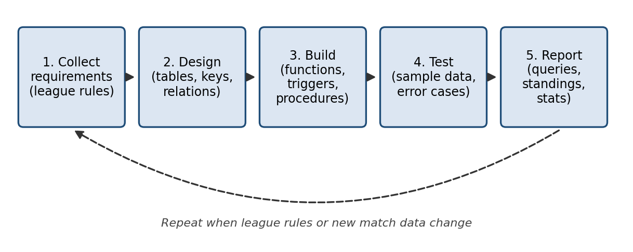
Fig 1.1: Development lifecycle of the project
Phase | Activity | Duration
Phase 1 | Problem definition and planning | 17 Oct – 18 Oct 2026
Phase 2 | Database design and creation of tables | 19 Oct 2026
Phase 3 | Writing functions, triggers and procedures | 20 Oct 2026
Phase 4 | Loading sample data, testing and screenshots | 21 Oct 2026
Phase 5 | Report writing and revision | 21 Oct – 22 Oct 2026
Phase 6 | Finalisation and submission | 23 Oct 2026
Table 1.2: Estimated Timeline of the Project
Chapter 2: Literature Review / Background Study
2.1 Timeline of the Reported Problem
Sports results were first recorded in paper scorebooks and the points table was calculated by hand. Spreadsheets later made the arithmetic easier, but the data still depended on one person typing it correctly. Larger competitions moved to databases, and modern relational databases can also store business rules inside the database as functions, procedures and triggers, so that the rules apply to every user in the same way.
2.2 Existing Solutions
- Paper scorebooks: Cheap, but slow to summarise and impossible to query.
- Spreadsheets: Easy to share, but formulas can be overwritten and there is no protection against invalid entries.
- Commercial league software: Feature-rich, but costly, closed and hard to customise for local rules.
- Relational database with stored programs (MySQL): Free and transparent; the points system and the validation checks are written once and apply automatically. This is the approach chosen here.
2.3 Bibliometric Analysis
Database textbooks describe stored procedures, functions and triggers as the standard way of enforcing business rules close to the data. Triggers are the basis of “active” databases that react to events such as an INSERT, and cursors allow row-by-row processing. Sports-analytics literature prefers composite indicators (such as efficiency ratings) to raw totals, but warns that a rating built from a few statistics ignores defence and team play.
2.4 Review Summary
Simple and transparent rules are more useful to coaches and organisers than complex models. A rating of points plus rebounds plus assists plus steals is easy to explain, although it weighs every statistic equally; this project keeps the formula visible and states the limitation clearly.
2.5 Problem Definition
Given teams, players, matches and player statistics, the problem is to (i) store them in related tables that prevent inconsistent data, (ii) update the points table automatically after every match, (iii) calculate an efficiency rating and grade for every player, (iv) list the top scorers and the wins of each team, and (v) reject invalid input, all using stored programs in MySQL.
2.6 Goals / Objectives
- Goal 1: Create a league database with primary keys, foreign keys and UNIQUE constraints.
- Goal 2: Create reusable functions and use them inside SELECT queries.
- Goal 3: Create triggers and procedures that maintain the standings and give clear error messages.
- Goal 4: Document the project in the MCA project-file format with diagrams, tables, screenshots and code.
Chapter 3: Design Flow / Process
The design follows a simple pipeline: the tables are created, the functions and procedures are written, the triggers are attached, and sample data is loaded so that every part can be tested. All the code is in one script so that the database can be rebuilt with one click.
3.1 Evaluation & Selection of Features
The league has five entities: teams own players, two teams play a match, every player has statistics in each match, and every team has one row in the points table (Table 3.1). Raw point totals were rejected as the only measure of a player, so three derived values were implemented as stored functions (Table 3.2).
Table | Key columns | Purpose
teams | team_id (PK), team_name (UNIQUE), city, coach | Participating teams
players | player_id (PK), team_id (FK), position, jersey_no | Players; jersey number unique within a team
matches | match_id (PK), team1_id, team2_id, scores, winner_id | Result and winner of each match
player_stats | stat_id (PK), match_id (FK), player_id (FK) | Points, rebounds, assists, steals, minutes per match
standings | team_id (PK, FK), played, won, lost, points | Points table, kept up to date by triggers
Table 3.1: Tables of the database basketball_db
Function | Rule | Meaning
calc_efficiency | points + rebounds + assists + steals | Contribution of a player in one match
get_player_grade | 40 or more: Star; 25 to 39.99: Starter; below 25: Bench | Grade from the average efficiency
get_team_wins | COUNT of matches won by the team | Number of wins of a team
Table 3.2: Stored functions of the project
3.2 Design Constraints
- Sample data: Only four teams, eight players and four matches are used, and the names and statistics are illustrative values, not official records; the method is the point of the project.
- Metric and platform: The rating is a simple sum that ignores defence, and Oracle PL/SQL syntax cannot run in MySQL Workbench, so MySQL syntax (DELIMITER, HANDLER, SIGNAL) is used for the same ideas.
3.3 Analysis of Features and Finalisation Subject to Constraints
The efficiency rating was kept as a simple sum so that it stays transparent. The grade slabs were chosen after looking at the sample data, so all sampled players grade as Starter or better. A win earns two points and a loss one point, so every match adds exactly three points to the table, which gives a simple check on the standings. Basketball matches cannot end in a draw, so equal scores are rejected, and a player’s minutes must lie between 0 and 60 to allow for extra time.
3.4 Design Flow
The project runs in five stages: create the tables, the functions, the triggers and the procedures, then insert the sample data and run the queries. The order matters because triggers must exist before data is inserted. Fig. 3.1 shows the entity-relationship diagram.
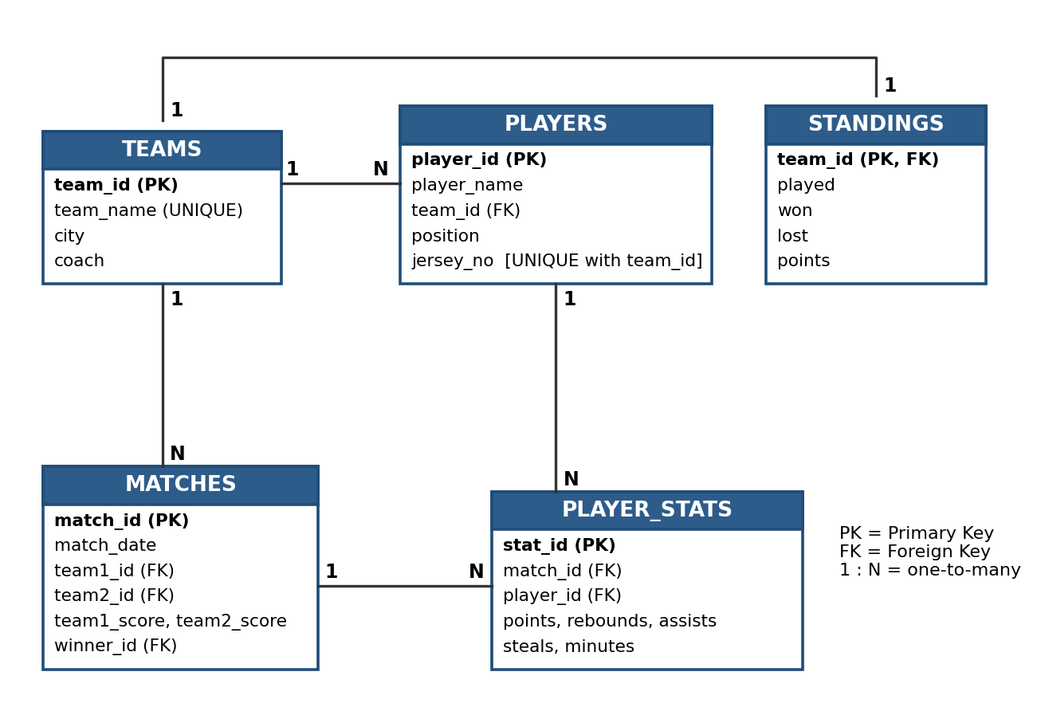
Fig 3.1: Entity-relationship diagram of basketball_db
3.5 Design Selection
A relational design with the rules stored inside the database was selected instead of a spreadsheet because it is reliable and every user receives the same behaviour, even when data is entered directly through SQL. MySQL Workbench was chosen because it is free and shows every result and error message clearly.
3.6 Implementation Plan / Methodology
Table 3.3 summarises the triggers and procedures. When a match is recorded, record_match validates the input, decides the winner and inserts the match, and the trigger then updates the points table.
Object | Type | What it does
trg_team_standings | Trigger on teams (AFTER INSERT) | Creates a standings row for every new team
trg_match_standings | Trigger on matches (AFTER INSERT) | Winner: +1 won, +2 points; loser: +1 lost, +1 point
trg_validate_stats | Trigger on player_stats (BEFORE INSERT) | Rejects negative statistics and minutes outside 0 to 60
add_player | Procedure with exit handlers | Adds a player; handles duplicate jersey (1062) and invalid team (1452)
record_match | Procedure with SIGNAL | Validates teams and scores, finds the winner, inserts the match
top_scorers(n) | Procedure with CURSOR | Returns the top n players by total points
Table 3.3: Triggers and procedures of the project
Steps to run the project in MySQL Workbench: Connect Workbench to the local instance, open basketball_project.sql (File → Open SQL Script) or paste the code into a new SQL tab, and click Run once; the script drops and recreates basketball_db, so it can be re-run safely. Check the Output panel for green ticks, open the Result tabs to see the query outputs, and test the invalid inputs one at a time, because an error stops a script.
Chapter 4: Results Analysis and Validation
4.1 Implementation of the Solution
The script was run in MySQL Workbench on MySQL Community Server 9.6. The script creates the database with its five tables, the three stored functions, the triggers and the procedures (all code is given in the Application Code section). A web front end (Flask in Python with HTML and JavaScript) was then connected to basketball_db; it only calls these stored programs, so every rule is still enforced by MySQL. Fig. 4.1 shows the forms for recording a match and adding a player, and Fig. 4.2 the forms for adding player statistics and a team.
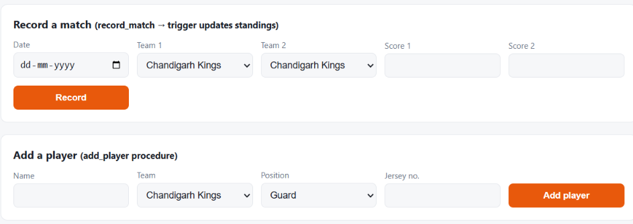
Fig 4.1: Front end: forms to record a match and add a player
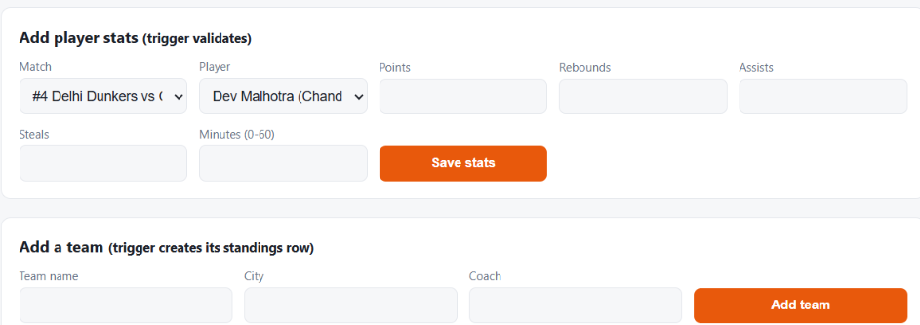
Fig 4.2: Front end: forms to add player statistics and a team
The sample data was then inserted: teams, players and statistics with INSERT statements, and the four matches by calling record_match, so that the winner is decided by the procedure and the standings are updated by the trigger (Table 4.1).
match_id | match_date | Team 1 | Team 2 | Score | Winner
1 | 2026-10-01 | Punjab Panthers | Delhi Dunkers | 85 – 78 | Punjab Panthers
2 | 2026-10-03 | Mumbai Hoopers | Chandigarh Kings | 92 – 88 | Mumbai Hoopers
3 | 2026-10-05 | Punjab Panthers | Mumbai Hoopers | 80 – 84 | Mumbai Hoopers
4 | 2026-10-07 | Delhi Dunkers | Chandigarh Kings | 70 – 75 | Chandigarh Kings
Table 4.1: Matches (matches table)
Sixteen player-statistics rows (four players per match) were inserted and accepted by the validation trigger. Fig. 4.3 shows the Matches page of the front end with the four recorded matches, and Fig. 4.4 shows the Standings page afterwards.
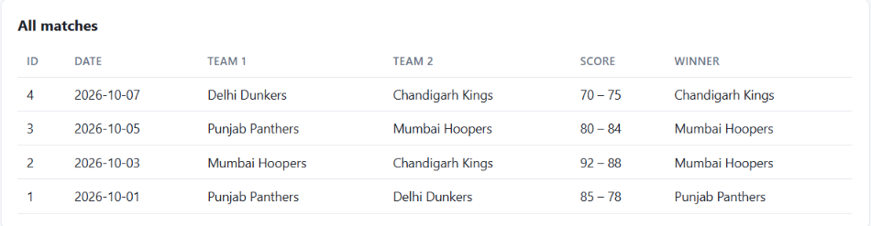
Fig 4.3: Matches page of the front end (four matches recorded by record_match)
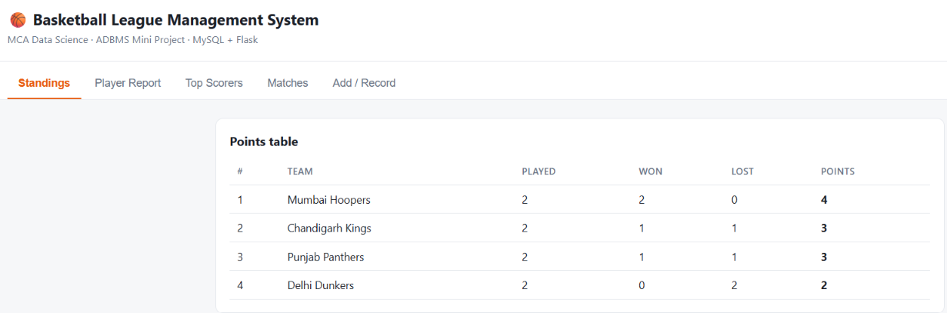
Fig 4.4: Standings page after four matches (by trigger)
4.2 Query Output and Interpretation
No UPDATE statement was written for the standings: the trigger trg_match_standings updated the rows after every call to record_match. The player report (Fig. 4.5 and Table 4.2) is the main output of the project: one SELECT joins players, teams and player_stats and calls calc_efficiency and get_player_grade inside the query, just as a PL/SQL function is used inside a SQL statement.
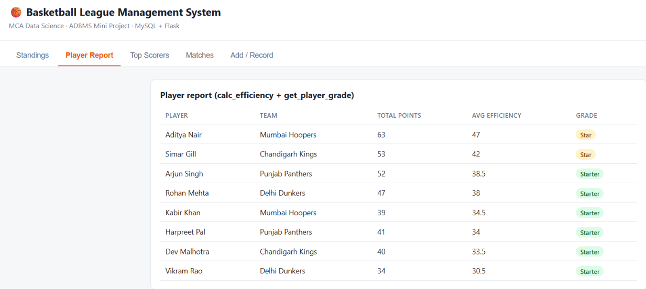
Fig 4.5: Player report page using calc_efficiency and get_player_grade
player_name | team_name | total_points | avg_efficiency | grade
Aditya Nair | Mumbai Hoopers | 63 | 47.00 | Star
Simar Gill | Chandigarh Kings | 53 | 42.00 | Star
Arjun Singh | Punjab Panthers | 52 | 38.50 | Starter
Rohan Mehta | Delhi Dunkers | 47 | 38.00 | Starter
Kabir Khan | Mumbai Hoopers | 39 | 34.50 | Starter
Harpreet Pal | Punjab Panthers | 41 | 34.00 | Starter
Dev Malhotra | Chandigarh Kings | 40 | 33.50 | Starter
Vikram Rao | Delhi Dunkers | 34 | 30.50 | Starter
Table 4.2: Player report (total points, average efficiency and grade)
The cursor procedure top_scorers(3) returned Aditya Nair (63), Simar Gill (53) and Arjun Singh (52) in rank order (Fig. 4.6). Fig. 4.7 charts the average efficiency of every player from Table 4.2.
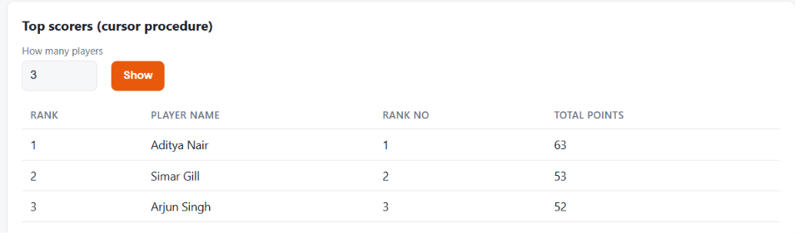
Fig 4.6: Top scorers page: output of CALL top_scorers(3)
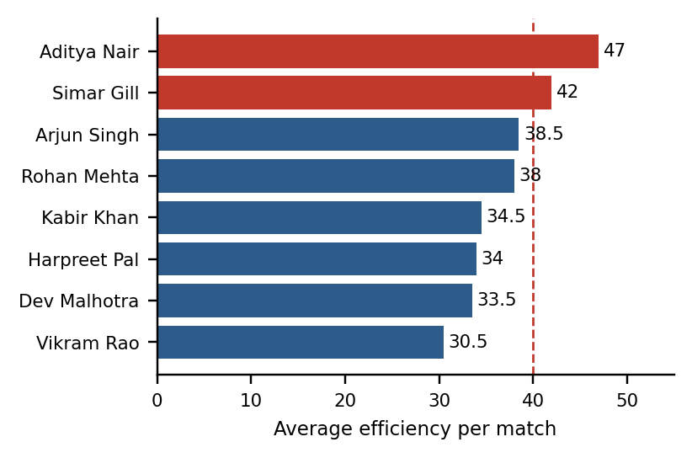
Fig 4.7: Average efficiency of each player
Interpretation of the results
- Standings: Mumbai Hoopers lead with two wins and 4 points; Punjab Panthers and Chandigarh Kings have 3 points each and Delhi Dunkers 2. The total of 12 points equals 4 matches × 3 points, which confirms that the trigger awarded points correctly for every match.
- Top performers: Aditya Nair has the most points (63) and the best efficiency (47.00); Simar Gill follows (53 points, 42.00). Only these two cross the Star limit of 40; the other six are Starters.
- Efficiency versus points: Harpreet Pal scored more points than Kabir Khan (41 against 39) but has a lower efficiency (34.00 against 34.50), because Kabir Khan contributed 19 assists. This is why efficiency gives a fairer picture than total points.
4.3 Validation and Exception Handling
Five invalid inputs were tried (Table 4.3). Two are caught by exit handlers inside add_player and returned as friendly messages; three are rejected with MySQL error 1644 raised by SIGNAL in record_match or in the trigger trg_validate_stats. A rejected statement inserts nothing. Fig. 4.8 to 4.12 show the actual outputs.
No. | Test statement | Rule tested | Observed result
1 | add_player('Test Player', 1, 'Guard', 7) | UNIQUE (team_id, jersey_no); handler 1062 | Error: jersey number already taken in this team
2 | add_player('Test Player', 99, 'Guard', 30) | Foreign key to teams; handler 1452 | Error: invalid team id
3 | record_match('2026-10-10', 1, 1, 80, 70) | A team cannot play itself (SIGNAL) | Error 1644: A team cannot play itself
4 | record_match('2026-10-10', 1, 2, 75, 75) | No draws in basketball (SIGNAL) | Error 1644: Basketball matches cannot end in a draw
5 | INSERT into player_stats with points = −5 | Trigger trg_validate_stats | Error 1644: Stats cannot be negative
Table 4.3: Validation tests and observed results
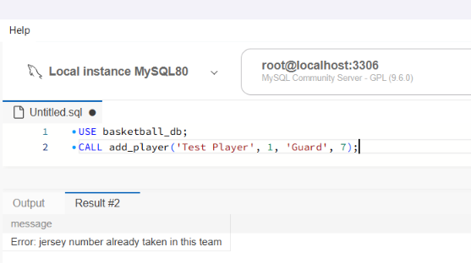  Fig 4.8: Test 1 – duplicate jersey number | 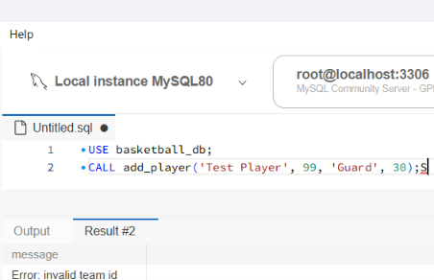  Fig 4.9: Test 2 – invalid team id | 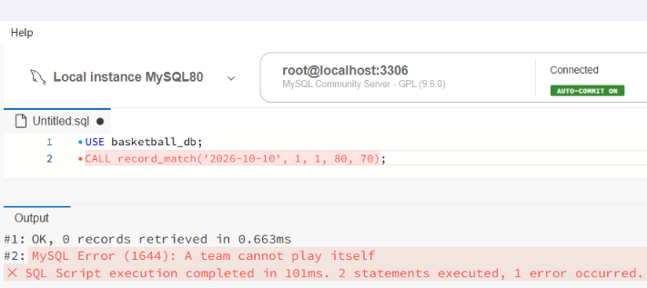  Fig 4.10: Test 3 – team plays itself
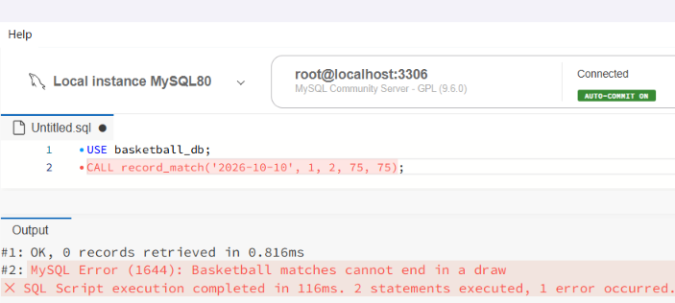  Fig 4.11: Test 4 – drawn match rejected | 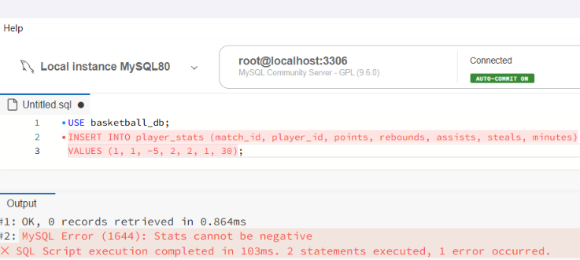  Fig 4.12: Test 5 – negative statistics rejected
All five tests behaved as designed, so invalid data cannot enter the database, which protects the standings and the player reports. The trigger also rejects minutes outside 0 to 60; this rule is part of the same trigger but is not shown in a separate screenshot.
Chapter 5: Conclusion and Future Work
5.1 Conclusion
This mini project built a basketball league database in MySQL and used stored functions, procedures, triggers and a cursor to automate its rules. The standings were updated automatically after every match, the player report used two functions inside a SELECT statement, the cursor procedure returned the top scorers in order, and all five invalid inputs were rejected with clear messages. Mumbai Hoopers led the table, Aditya Nair was the top scorer and most efficient player, and efficiency gave a fairer ranking than total points alone.
Limitations are that the data is a small set of sample values, that the efficiency rating weighs every statistic equally, and that MySQL’s stored-program syntax differs from Oracle PL/SQL even though the concepts are the same.
5.2 Future Scope
- Richer ratings: Add weights and more statistics such as turnovers, blocks and shooting percentage.
- Larger data: Load a full league over several seasons and add season-wise views.
- Front end: Build a web application (for example with JSP and JDBC) that calls these procedures.
- Oracle version: Port the logic to Oracle PL/SQL packages and compare the two languages.
References
1. Elmasri, R., & Navathe, S. B. Fundamentals of Database Systems. Pearson Education.
2. Silberschatz, A., Korth, H. F., & Sudarshan, S. Database System Concepts. McGraw-Hill Education.
3. Ramakrishnan, R., & Gehrke, J. Database Management Systems. McGraw-Hill Education.
4. Feuerstein, S., & Pribyl, B. Oracle PL/SQL Programming. O’Reilly Media.
5. Oracle Corporation. MySQL Reference Manual (Stored Objects: stored routines, triggers and cursors). https://dev.mysql.com/doc/
6. Oracle Corporation. MySQL Workbench Manual. https://dev.mysql.com/doc/workbench/en/
7. http://127.0.0.1:5000
8. GitHub - https://github.com/ashutoshdash8/-Basketball-League-Management-System-.git
Chapter 6: Diagrams & Use Cases
6.1 Block Diagram
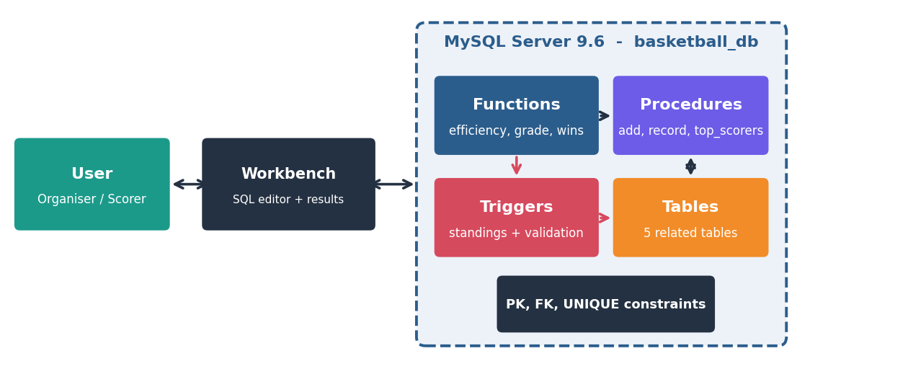
Fig 6.1: Block diagram
6.2 Use Case
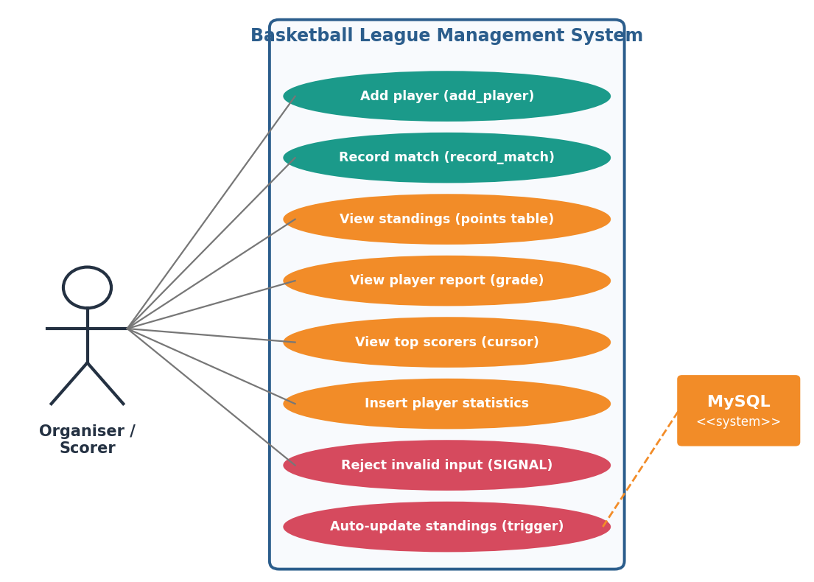
Fig 6.2: Use case diagram
6.3 Workflow
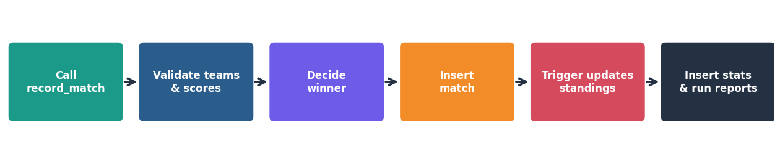
Fig 6.3: Workflow diagram (recording a match)
6.4 Future Enhancement Roadmap
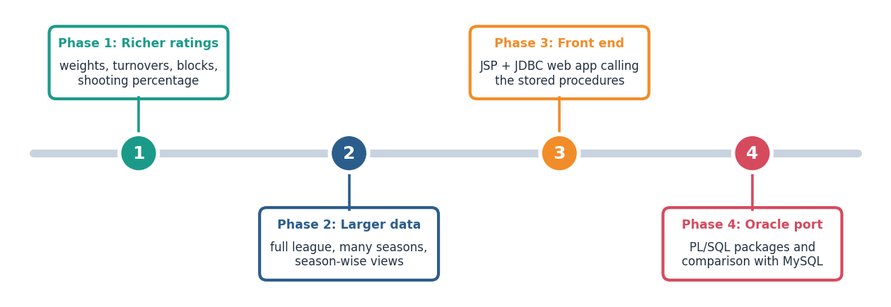
Fig 6.4: Future enhancement roadmap
Chapter 7: Project Repository & GitHub
The complete script basketball_project.sql (tables, functions, triggers, procedures, sample data, demonstration queries and error tests) is kept in the project repository. Running it once in MySQL Workbench rebuilds the whole database.
GitHub: https://github.com/ashutoshdash8/-Basketball-League-Management-System-.git

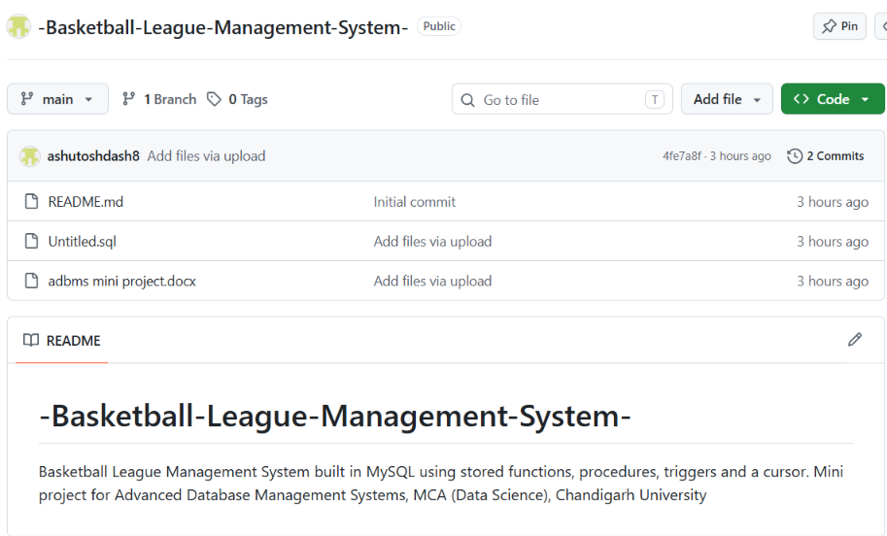
Fig 7.1: GitHub

